As the end of another school year approaches, we wish to keep
you up to date with our recent School News.

- We recently participated in a Soccer Blitz in Cootehill and an Athletics event in Shercock. Well done to the boys and girls
who took part. Also congratulations to Niamh Shanley who represented our school in the Cavan Spelling Bee competition.
- We held our annual Down Syndrome HB Ice Cream Party on Thursday 9th June which was very enjoyable and resulted in a donation of €130 to this worthy cause.
- We held a very enjoyable “Active Week” from 25th to 29th April which included activities such as basketball, football, hockey, rounders and parachute games. The good news is
that we have been successful in achieving the Active Flag.
- A very enjoyable Science Gallery sponsored by ESB Ireland
took place in our school on 27th May for all classes.
- A Fire Prevention Officer visited 3rd and 4th class on 13th April.
- Mairead Galligan and John Joe Rogers spoke to all classes on
8th April re Running and Fitness.
- Chris Thompson from Poetry Ireland gave a presentation to all classes on 18th April.
- Our senior students travelled to Cavan Library in March to attend Science Labs and also to Bailieboro Library in April to take part in “Irish History Live”.

All staff at the school have recently completed a First Aid training course facilitated by Baileborough Red Cross.

Our End of Year Graduation Mass will be celebrated on Monday
20th June at 10 am in St. Brigid’s Church. All parents, family and community members are welcome to attend.

All school tours are being held this week. We hope that the
children enjoy themselves and that the weather is favourable. We thank the Parents Association for sponsoring the buses again this year.

We are very grateful to all those parents who use the Clothing Bank which contributes greatly to school funds. If the container appears full during the summer holidays, please ring Cash for Clobber at 0044 7717377738 and ask to have it emptied.

Induction Parent Evening and Induction Afternoon for 2016 Junior Infants are being held next week. We wish to take this opportunity to welcome all new pupils to St. Brigid’s N.S.

Sports day was held on Thursday June 9th. We were blessed
with good weather and we extend our sincere thanks to the
Parents Association and the chefs involved for providing a delicious BBQ. A great day was had by all!

Congratulations to the boys and girls from 6th class who received the sacrament of Confirmation on 1st May and also to the 2nd class children who made their First Holy Communion on 15th May. We thank all the children who took part in the choir and all those who played musical instruments at Holy Communion and made their day so special.

School calendar for next year, reports and book lists are being
given out today. Please feel free to contact the school if you wish to speak to your child’s class teacher in relation to these.

Tuition in brass instruments has continued throughout the school year. The Brass Duffers are going from strength to strength as demonstrated by their performance recently at First Communion.

Together with schools nationwide, we raised the Irish Flag on
15th March. We also raised our Health Promoting Flag recently.
We were presented with our second Green Flag at a
ceremony in the Helix, Dublin on 26th May and this will be raised on Friday June 17th.

Since the construction of our new bicycle shelter, lots of students are now cycling to school. It is great to see the children enjoying this healthy exercise! Please remember to send in the consent form if your child is cycling.

Many thanks to Knockbride Variety Show for their generous donation of €1000 and to Maudabawn Gun Club for their
welcome gift of €200.

Children from 1st to 6th class have been enjoying basketball
lessons over recent months under the direction of Ms O’Kane, our in-house coach.

A new School Crest has been designed . Thanks to all the children who submitted suggestions. Our new crest is based on an idea by Luke Carolan
in 5th Class.

Our new desktop computers are up and running and are a great asset to our IT facilities. We are grateful to the Parents
Association for their assistance in this regard.

Our new tennis facilities are now in use and are a big hit
with all students. Many thanks to Marian, our in-school “Tennis Coach” in this regard.

We have extended our “Coin Collection” fundraiser until the end
of this school year so please check out all those places where your spare coins are hiding! We are past level 2 at this stage and are hopeful to reach level 4 so that we can enjoy watching Ms Haughey do the “ice bucket” challenge before we go on our summer holidays!

We extend a big “ Thank You” to the Parents Association and all who helped out at our school during the year.

The school garden has been planted by the children and has produced a fine crop of lettuce, carrots, onions, spinach and beetroot.

Class Allocation/Teacher list for September 2016
Ms Skelly – Infant Teacher

Ms Fitzpatrick – 1st and 2nd Class Teacher

Ms Carron – 3rd and 4th Class Teacher

Ms O’Kane – 5th and 6th Class Teacher/Deputy Principal

Ms Haughey – Learning Support/Principal

Ms Farrelly - Resource Teacher

After 12 years of teaching infants in St. Brigid’s, Ms Haughey is excited to be moving to Learning Support as she will now have the opportunity to work and strengthen her relationship with all the children in the school through team teaching and in-class support.

MATHS PROMPT SHEETS for parents (how to help your children
with maths) are now available to view on our website.

Parents are invited to browse our SCHOOL WEBSITE at tunnyduffns.schoolsites.ie to view photographs of recent events
and keep up to date on policies, school activities, classroom work etc.

We close for the summer holidays at 12 o’clock on Thursday 23rd June and re-open on Thursday 1st September. Children are
required to have full uniform and all books from book list for the
first day back.
We wish everyone a happy and safe holiday!

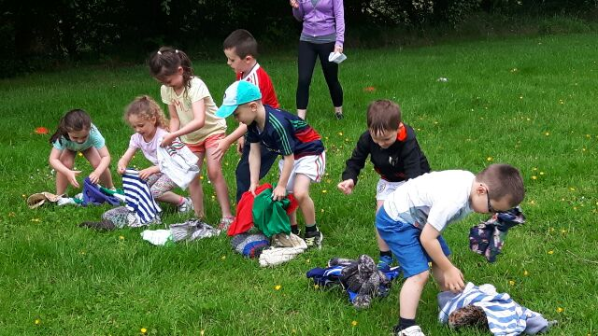
SPORTS DAY JUNE 9TH
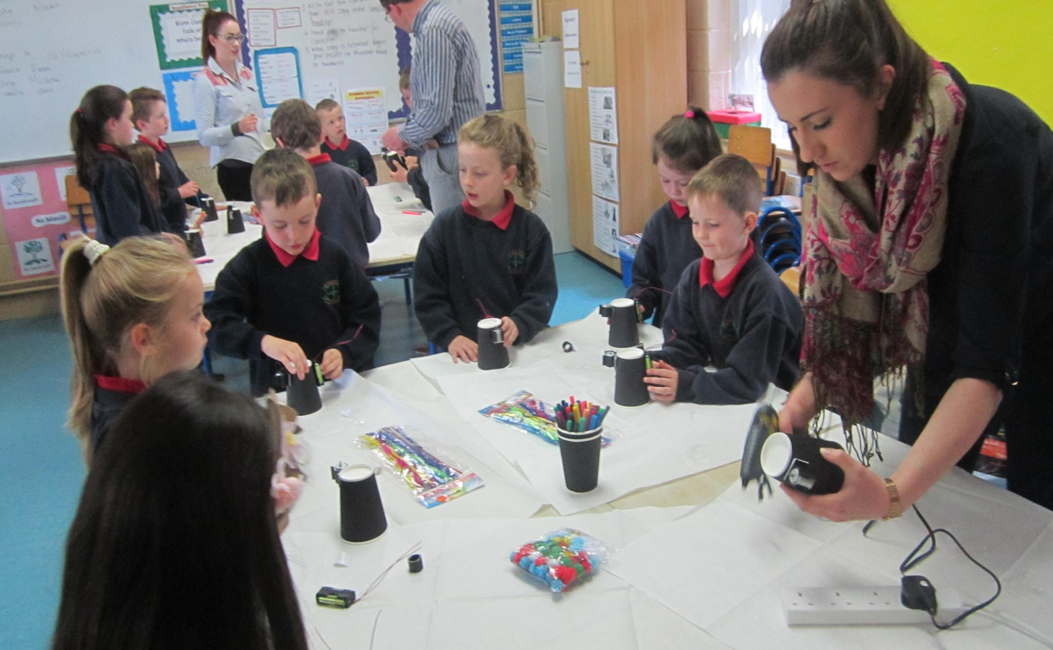
SCIENCE GALLERY DAY MAY 27TH

