St Brigid’s N.S.
13th June 2019
As we approach the end of another school year, we wish to keep you up to date with our School News.
- We recently participated in a boys’ and girls’ Soccer Blitz in Cootehill and a Relay event in Clones. Well done to Victor who won a bronze medal in the “King of the Sprint” and all the boys and girls who took part!
- We held a Down Syndrome Wacky Socks/Hair Day on 21st March which was great fun and resulted in a donation of €180 to Down Syndrome Support Cavan.
- A very enjoyable “Be Active” after-school programme was held on Tuesdays from 15th April to 19th June which included activities such as basketball, football, hockey, rounders, athletics etc. We then held “Active Week” from 5th to 8th June. Thanks to Mr McPhillips for all his hard work.
- Our GAA coach, Graham (who was organised by Knockbride Club) has been teaching football skills to all students over the last few months.
- A successful Scholastic Book Fair was held in April resulting in commission of €280 for books to be purchased for the school.
- A Fire Prevention Officer visited 3rd and 4th class on 27th March.
- Our annual Sports Day took place on 13th June. We had a great day and the Parents Association provided a delicious BBQ for all.
- Tennis training continues to be very popular and has been on-going since Easter. A mini tournament has been organised for 6th class, the final of which will take place next week.
- Our Senior Girls recently competed in GAA Cumann na mBunscol competition. They played well and reached the semi-finals. Thanks to Mr O’Connor and Ms Fitzpatrick for their hard work.
- Many thanks to the children who performed at this year’s Variety Show and to the committee for their generous donation of €2000 towards school funds.

The Brass Duffers are going from strength to strength as demonstrated by their performances recently at First Communion and Confirmation.

Our End of Year Graduation Mass will be celebrated on Wednesday 26thJune at 10 am in St. Brigid’s Church. All parents, family and community members are welcome to attend.

Congratulations to the 12 boys and girls from 6th class who received the sacrament of Confirmation on 24th May In East Knockbride Church and also to the 10 children from 2nd class who made their First Holy Communion on 12th May In St. Brigid’s Church, Tunnyduff. We thank all the children who took part in the choir and who played musical instruments and
made their days so special. Thanks to their teachers, Ms Fitzpatrick, Mr McPhillips, Mr O’Connor and Ms Haughey for their continued dedication in preparing the children for these sacraments. A very special thank you to the parents who provided lovely refreshments after Holy Communion.

Green Schools – We have commenced working towards our 4th Green Flag which is for sustainable modes of transport. We have held many workshops throughout the year – scooting skills, bicycle maintenance, cycle skills and helmet fitting. We had a very successful “Walk to School Week” in May. We introduced “The Golden Boot Award”. Ms Reynolds wishes to thank parents, staff and pupils for your continued support.

Please note that we are obliged to notify TUSLA (Child and Family Agency) if a child is absent from school for 20 days or more in the school year. Please remember to send in a note when your child returns to school after a period of absence.

All school tours have recently been held. The venues proved very popular and all the children had a great time.

Induction Parent Evening for 2019 Junior Infants is being held on Thurs 13th June from 6.30 to 7.30pm and Induction Afternoon for the children takes place on Friday 14th June from 1 to 2 o’clock. We wish to take this opportunity to welcome all new pupils to St. Brigid’s N.S. for Sept 2019.

We extend a big “ Thank You” to the Parents Association and all who helped out at our school during the year. A Tractor Run organised by the Parents Association in March made a fantastic profit of €3200 for school funds.

We are very grateful to all those parents who use the Clothing Bank which contributes greatly to school funds. A total of €826.50 has been raised in this school year to date, which includes €115 resulting from the “Cash for Cobber Blitz”. If the container appears full during the summer holidays, please ring Cash for Clobber at 0044 7717377738 and ask to have it emptied.

Our BAG PACKING evening in Super Valu, Bailieborough was a huge success and added €830 to our school fundraising efforts. Many thanks to the parents who gave their time so generously. Our Easter Draw was also very successful, making a profit of €180.

We are grateful to all those parents who pay their school bills via epayments which has resulted in a safer and more efficient accounting system. All you need to do is click on the link that is sent to your email and enter your debit or credit card details.

Parents are invited to browse our SCHOOL WEBSITE at tunnyduff.weebly.com to view photographs of recent events
and keep up to date on policies, school activities, classroom work etc.

The school photographer is booked for the next school year – 11th September 2019

We close for the summer holidays at 12 o’clock on Wed 26th June and re-open on Thurs 29th August. Children are required to have full uniform and all books from their book lists for the first day back.

We are constantly reminding our students about the importance of road safety, water safety and farm safety, so please do take care during the summer holidays
We wish everyone a happy and safe holiday
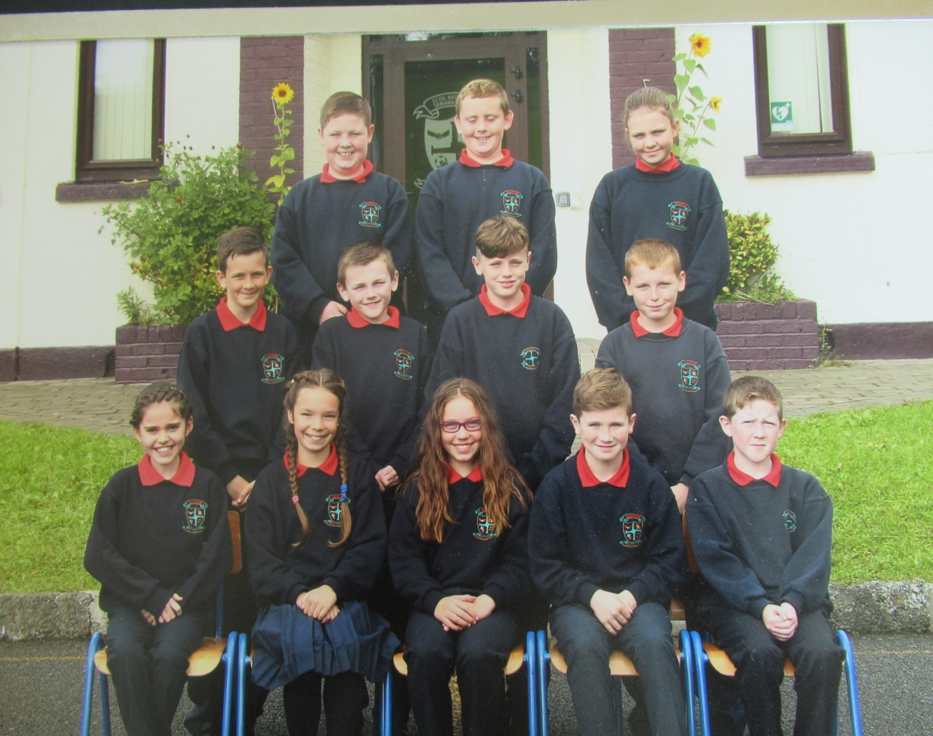
Best wishes to our 6th class pupils who are embarking on the new challenge of Secondary School after the summer holidays.

