St. Brigid’s N.S.
Newsletter
June 2023

As we approach the summer holidays, we reflect on a successful school year where we thankfully are back to ‘normal ‘after the pandemic.

- Huge congratulations to our Girls Cumann na mBunscol football team who won their final in Breffni Park on June 7th. Wonderful achievement – you have done your school proud! Aoife Rogers was also awarded Player of the Match. Many thanks to Mr McPhillips for his excellent coaching work. He was ably assisted by Alan and Kieran. Well done also to our Boys team who only lost one match in their league but unfortunately didn’t make it to the final. We congratulate Dylan Daly who represented us in Breffni Park at the mini games during the Cavan v Armagh match.

- Tennis training continues to be very popular and has been ongoing since the beginning of May. Congratulations to Finn Reilly who won the 6th class singles tournament.

- GAA training has been ongoing with Coach Alan on a fortnightly basis while County Board Coach Karen has been here every second week since Easter.
- Congratulations to the boys and girls who celebrated their First Holy Communion on May 15th and their Confirmation on May 5th.

- School tours have all taken place. The children appear to have really enjoyed their time out together.

The Green Schools Committee have been working tirelessly in the Garden over the year and have produced a range of vegetables including lettuce, onions and potatoes as well as strawberries and a great selection of flowering plants.

Induction meeting for parents of children starting in Junior Infants in September was held on Thursday 15th June at 6 o’clock and the new students came into school for a “Meet and Greet” session on Friday 16th June from 1 to 2 pm. “Moving on Day” also took place for the rest of the school on this day.
We wish to take this opportunity to welcome all new pupils to St. Brigid’s N.S. for the next school year.

The school photographer is booked for next year – Tuesday 5th September 2023.

We are very grateful to all those parents who use the Clothing Bank which contributes greatly to school funds. A total of €1522 has been raised in this school year to date. If the container appears full during the summer holidays, please ring Cash for Clobber at 048 94478880 (Billy) and ask to have it emptied.

Thank you sincerely for now using the direct payment system which is a much more efficient and safe method for us all.

Parents are invited to browse our SCHOOL WEBSITE at tunnyduff.weebly.com to view photographs of recent events
and keep up to date on policies, school activities, classroom work etc.

Friendship bracelets were sold during Friendship Week 27th to 31st March. €175 was raised for Amnesty International.

As you are probably aware, the Government recently introduced a “Free Book Scheme” whereby all schools have now received a grant to purchase textbooks, workbooks and copybooks. We very much appreciate the help from parents with Book Covering over the last few weeks, thank you sincerely.

Please note that we are obliged to notify TUSLA (Child and Family Agency) if a child is absent from school for 20 days or more in the school year. Please remember to send in a note when your child returns to school after a period of absence.

An End of Year Service/6th Class Graduation ceremony will be celebrated on Thursday 22nd June in Tunnyduff Church at 12 noon. Parents and local community are invited to attend.

Active Week/Sports Day is taking place during this week, 20th to 23rd June. Children will engage in various activities, which have been organised by 5th and 6th class under the direction of Mr McPhillips.

Sports Day was held on June 19th at the GAA pitch in Canningstown. We all had a great day, with pleasant weather and a delicious food which was provided by the Parents Association. We wish to thank them for this and all their efforts over the past year.

The Setanta book fair, which was organised by Ms Fitzpatrick, was held recently and proved to be a great success. The commission earned by the school has been spent by updating the reading resources for each classroom.

We are most grateful to local businesses, SNS Hardware Ltd and McCabe Feeds Ltd for their sponsorship of sports jerseys for our boys and girls.

We are delighted to congratulate Aoife Rogers on being chosen to play in Croke Park on All Ireland Semi-Final day on 15th July in the GAA INTO Mini Sevens games. It is a wonderful honour for Aoife and her family and we wish them a very enjoyable day.

We close for the summer holidays at 12 o’clock on Friday 23rd June (bus will run at that time) and re-open on Thursday 31st August. Children are required to have full uniform and all items from their book lists for the first day back.

We are constantly reminding our students about the importance of road safety, water safety and farm safety, so please do take care during the summer holidays

We wish everyone a happy and
safe holiday

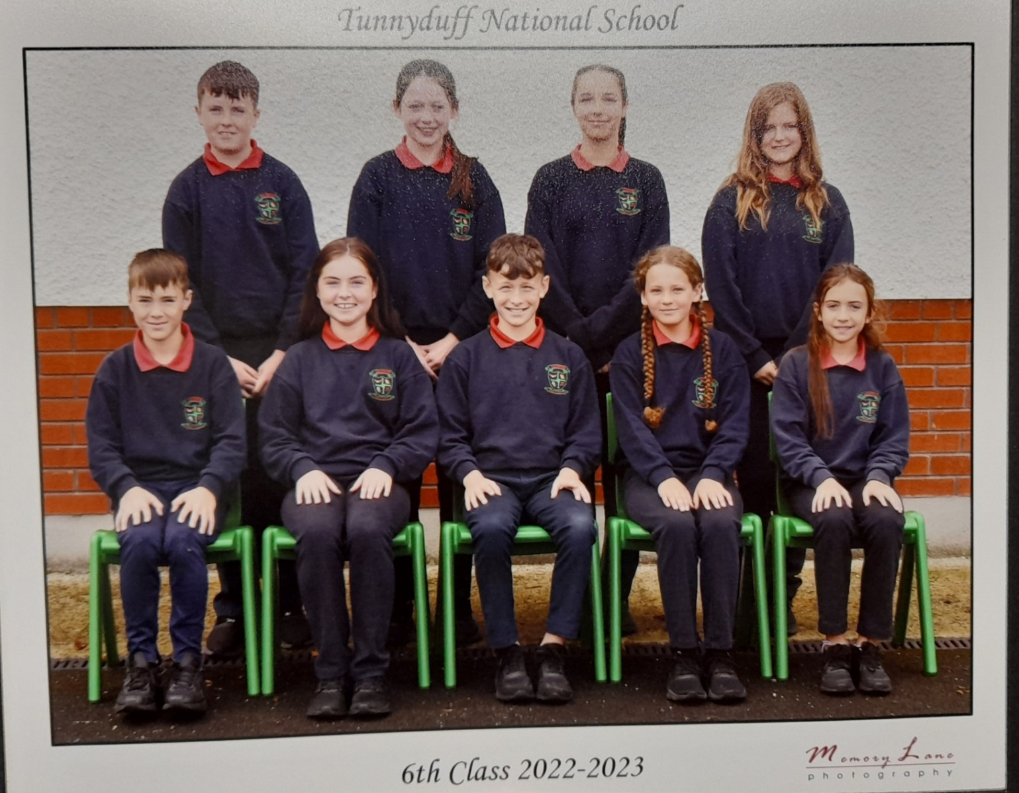

Best wishes to our 6th class pupils who are embarking on the new challenge of Secondary School after the summer holidays.

